

Chemistry ATAR 3+4

Acids & Bases Test : **SOLUTIONS : 54 MARKS**

# DO NOT MARK THIS PAPER

Q1. Which of the following volumes of a 0.040 mol L-1 potassium hydroxide solution is required to react exactly with 20.0 mL of a 0.010 mol L-1 diprotic acid?

A. 1.0 mL

B. 5.0 mL

C. 10.0 mL

D. 20.0 mL

Q2. Which of these salts will give a basic solution when added to water?

1. NH4NO3
2. NH4CH3COO
3. Ca(NO3)2
4. CaS

Q3. Which of the following is most **UNLIKELY** to act as both a Brönsted - Lowry acid or base?

A. OH─

B. HPO42─

C. HS─

D. NH4+

Q4.Which statement best describes the equivalence point in a titration between a strong acid and a strong base?

1. A. The point at which the first sign of a colour change occurs

B. The point at which equal moles of acid and base have been added together

C. The point at which equal moles of H+ ions and OH– ions have been added together

D. The point at which the rate of the forward reaction equals the rate of the reverse reaction

Q5. All the following are amphoteric except:

1. HSO41-
2. HPO42-
3. H2PO41-
4. PO43-

Q6. Sulfuric acid (H2SO4) and nitric acid (HNO3) are both strong acids. Ethanoic acid (CH3COOH) is a weak acid.

20.00 mL solutions of 0.10 M concentration of each of these three acids were separately titrated with a 0.10 M solution of sodium hydroxide (NaOH).

In order to react completely

A. all three acids would require the same amount of NaOH.

B. HNO3 would require more NaOH than CH3COOH but less than H2SO4.

C. H2SO4 and HNO3 would require the same amount of NaOH but CH3COOH would require less.

D. CH3COOH and HNO3 would require the same amount of NaOH but H2SO4 would require more.

Q7. Which of the following examples represents an acid-base reaction?

A. NH4+(aq) + OH─ (aq) → NH3(aq) + H2O(l)

B. 2NO3─(aq) + 2H+(aq) + 3H2O2(aq) → 2NO(g) + 3O2(g) + 4H2O(l)

C. 2K(s) + 2H2O(l) → 2K+ (aq) + 2OH─aq) + H2(g)

D. Ca2+(aq) + CO32─(aq) → CaCO3 (s)

Q8. Methanoic acid and azoic acid are both weak acids with the following acidity constants (equilibrium constants).

***K*a in M at 250C**

methanoic acid (HCOOH) 1.82 × 10─4

azoic acid (HN3) 1.91 × 10─5

Two separate solutions were prepared, one of 0.1 M methanoic acid and the other of 0.1 M azoic acid.

Which one of the following would be present in the highest concentration at 25oC?

A. HN3 in the azoic acid solution

B. N3─ in the azoic acid solution

C. HCOOH in the methanoic acid solution

D. HCOO─ in the methanoic acid solution

Q9. Acid *X* is 0.1 mol L–1 hydrochloric acid. Acid *Y* is 1.0 mol L–1 ethanoic acid.

How does acid *X* compare with acid *Y*?

1. A. *X* is weaker and more dilute than *Y.*
2. B. *X* is stronger and more dilute than *Y.*
3. C. *X* is weaker and more concentrated than *Y.*
4. D. *X* is stronger and more concentrated than *Y.*

Q10. Pure water undergoes self-ionisation. The equilibrium constant for the reaction at 95oC is 4.8 x 10─13. This corresponds to a pH of 6.2. Which of the following statements is true?

A. At 95oC the water is acidic.

B. At 95oC the water is neutral.

C. At 95oC the water is basic.

D. The pH has been worked out incorrectly.

1. Write net **IONIC** equations for any reaction that occurs in the following making sure to include phases in your answer, Also write **full observations**:

***NB: If no reaction occurs you must state this.***

[12 marks]

1 mark for molecular, 1 mark for net ionic inc states

a) Calcium hydroxide solid and sulphuric acid.

**►  *Ca(OH)2 (s) + 2H+(aq)+ SO4 2- (aq) → CaSO4(s) + 2H2O(l)***

**2**

***A white solid is added to a clear colourless solution. Upon addition the solid dissolves to leave a clear colourless solution and a white precipitate. 1 mark***

b) Strontium oxide powder and phosphoric acid.

**8**

**2**

***3SrO(s) + 2H3PO4(aq) → Sr3(PO4)2(s) + 3H2O(l)***

***A white solid is added to a clear colourless solution. Upon addition the solid dissolves and a white precipitate forms in a clear colourless solution. 1 mark***

c) Nitric acid and copper carbonate solution. Will give solid CuSO4

**2**

**► *2H+(aq)  +  CO32- (aq)  → H2O(l) + CO2 (g)***

***A blue solution is added to a clear colourless solution. Upon addition there is an effervescence of a colourless odourless gas and the solution remains blue. 1 mark***

d) Acetic acid solution and magnesium metal.

**2**

**►  *2CH3COOH (aq) + Mg (s) → Mg2+(aq)  +2CH3COO- (aq) + H2 (g)***

***A silvery metal is added to a clear colourless solution. Upon addition there is an effervescence of a colourless odourless gas and the solution remains clear and colourless. 1 mark***

2. Rewrite the following equations labelling the acids and bases with either an “A” or a “B” and show proton donation and acceptance with an arrow for both the forward and reverse reaction. State the conjugate acid/base pair and conjugate base/acid pair for each reaction:

**1**

1. CN-1 + H2O ⮀ HCN + OH-1

**B A CA CB**

**0.5**

**Conj. Acid/Base Pair = H2O / OH-**

**0.5**

**Conj. Base/Acid Pair = CN- / HCN**

**1**

1. CH3COOH + S2- ⮀ CH­3COO-1 + HS-1­­

**A B CB CA**

**0.5**

**Conj. Acid/Base Pair = CH3COOH / CH3COO-**

**0.5**

**Conj. Base/Acid Pair = S2- / HS-**

[4 marks]

3. Is a lithium oxalate solution acid, basic or neutral? Explain with the aid of a hydrolysis equation.

**1**

**► *BASIC***

C2O42- + 2H2O → H2C2O4  + 2OH-

**1**

[2 marks]

4. The Ka values for two acids are given in the table below:

|  |  |
| --- | --- |
| Acid | Ka @ 25°C |
| H2C2O4 | 5.4 x 10-5 |
| H3PO4 | 7.1 x 10-3 |

NB: These are the K values for the 1st ionisation only! i.e. Ka1

a) Of the two acids which is the strongest? Justify your answer using the Ka values.

**► H3PO4 is the strongest of these two weak acids, as its Ka value is higher indicating a greater extent of ionisation.**

**2**

b) Write equations to represent the first ionisation of each acid.

**1**

**► H2C2O4 + H2O** ⮀ **H3O+ + HC2O4-**

**1**

**► H3PO4 + H2O** ⮀ **H3O+ + H2PO4 -**

[4 marks]

5. Calculate the pH of (assume 250C):

1. A solution of 0.320 grams of HCl in 250mL of water.

**HCl n (HCl) = m**

**1.008 M**

**+ 35.45 = 0.320**

**36.458 g.mol-1 36.458**

**= 0.008777 mol**

**[H+] = [HCl] = n**

**3**

**V**

**= 0.008777**

**0.250**

**= 0.03511 M**

**pH = - log 10 [H+]**

**= - log 10 0.03511**

**= 1.45**

1. 75 mL of 0.15M NaOH is mixed with 2.5g of powdered Ba(OH)2

**n(NaOH) = CV**

**= 0.15x0.075**

**1**

**= 0.01125 mol**

**n(Ba(OH)2)=m/Mr**

**=2.5/(137.3+34)**

**1**

**=0.01459 mol**

**But as there 2 OH x 2**

**=0.02919 mol**

**1**

**Total OH- = 0.01125+0.02919 = 0.0404 mol**

**n(OH-) = CV**

**1**

**0.0404 = C x 0.075**

**= 0.538 molL-1**

**[H+] = 1 x 10 -14**

**[OH-]**

**1**

**= 1 x 10 -14**

**0.538**

**= 1.862 x 10-14**

**pH = - log 10 [H+]**

**= - log 10 (1.862 x 10-14)**

**1**

**= 13.7**

[6 marks]

6. A 4.65g sample of pure NaOH(s) is dissolved in 200mL of distilled water and added to 626mL of 0.15 mol.L-1 H2SO4(aq). Determine the pH of the mixture when the reaction is complete. Also state the limiting reagent.

**n (NaOH) = m n (H2SO4) = C x V**

**M**

**= 4.65 = 0.15 x 0.626**

**40**

**1**

**= 0.1163 mol = 0.0939 mol**

**H2SO4 + 2NaOH *→* Na2SO4  + 2H2O**

**2**

**So n (NaOH) = 2 x H2SO4n(H2SO4) = 2 x 0.0939 = 0.1878 mol**

**1**

**\* We only have 0.1163 mol of NaOH**

**∴ NaOH is the LIMITING REACTANT!**

**7**

* **n(H+) remaining = TOTAL - n(NaOH neutralised**

**1**

**= 0.1878 - 0.1163**

**= 0.07155 mol**

**[H+] = = n**

**V**

**1**

**= 0.07155**

**0.826**

**= 0.0866 M**

**pH = - log 10 [H+]**

**1**

**= - log 10 (0.0866)**

**= 1.06**

[7 marks]

7. Titrations are a very important analytical technique in Chemistry. Unfortunately, acids, bases and salts are generally all clear and colourless in solution, so the end point of a titration cannot be signified by a colour change as in a redox titration. We need to select an indicator which changes colour for us. However, the selection of the correct indicator is based on a few factors. In each case the acid is in the conical flask.

a) On your answer sheet, write down the missing entries *a* to *f* from the table below.

|  |  |  |
| --- | --- | --- |
|  | Strong Base | Weak Base |
| Strong Acid | 1. pH at end point = *a*  Indicator = *b* | 3. pH at end point = *e*  Indicator = *f* |
| Weak Acid | 2. pH at end point = *c*  Indicator = *d* |  |

**► a = 7**

**b = LITMUS or BROMOTHYMOL BLUE**

**c = 9**

**6 x 0.5 = 3**

**6**

**d = PHENOLPHTHALEIN**

**e = 5**

**f = METHYL ORANGE or METHYL RED**

b) The following titration curves are drawn for titrations 1,2 and 3 above. Match the titration to the correct curve. Write your answer in the form

“1A” or “1B”etc.

A B C

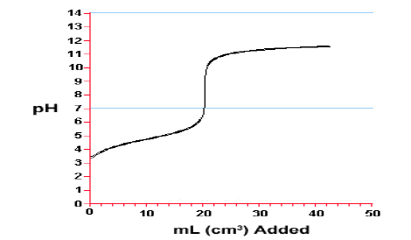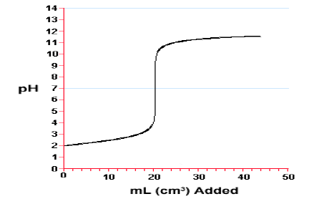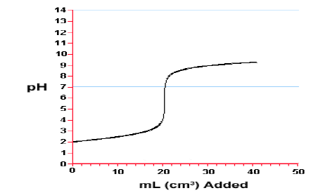

**► “1 B” = STRONG ACID v STRONG BASE**

**► “2 A” = WEAK ACID v STRONG BASE**

**3**

**► “3 C” = STRONG ACID v WEAK BASE**

[6 marks]

**END of PAPER**

**TOTAL MARKS = 54 Marks**